What to wear (and NOT wear) on camera
We’ve pulled together five of the most common on-camera situations, giving you insights on what to wear and what to avoid in these situations. Most of these rules apply in a variety of on-camera interview situations, but you’ll get the gist of what works and what doesn’t by scrolling through our demonstrations below.

Situation #1: Seated interview in a TV station
On set in a television station, you may be seated behind a desk, but more than likely you’ll be sitting in a chair face-to-face with your interviewer. Since your full body is likely to be shown, make sure you consider your appearance from head to toe.
You’ll likely be wired with a lapel microphone, but there also may be additional boom microphones to help pick up your sound. Women should be conscious of their hair and jewelry styling to make sure nothing gets caught up or picked up by the microphone.
Consider wearing fabrics that don’t show lines or wrinkle easily. If you plan on wearing slacks, be sure when you are seated, your pant length is appropriate and your socks are high enough to prevent any awkward leg from showing.
You should also avoid wearing red or green. Blue is always a winner on camera. And, if appropriate, consider adding a lapel pin to represent your organization, but nothing too ostentatious or shiny.
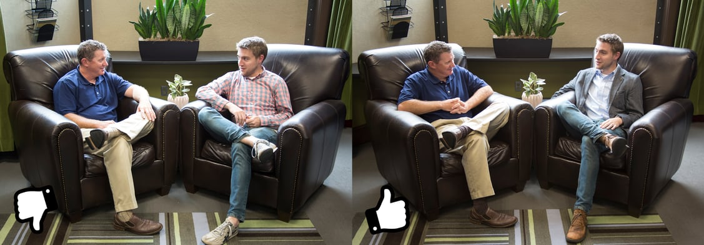

Situation #2: Remote interview outdoors
Many communicators have the opportunity to talk to the media outside of the studio. Whether it’s during an outdoor event or somewhere more scenic than a boring boardroom, you should be prepared for a circumstance that presents its own unique challenges when it comes to your dress.
With the sun bearing down, avoid lighter colors like white or khaki, which can wash you out and reflect the sun to the camera. This can help avoid the potential for a viral meme by preventing any embarrassing see-through blunders.
Since you’ll likely be wired with a lapel microphone, you’ll want to make sure you wear something that is conducive to being wired up. Having a belt on makes it easier to clip the microphone onto your body and having a top with a collar, pocket or button hole will more easily allow the microphone to be threaded through your clothes and hidden from view.
Depending on the weather (particularly the wind), make sure your hair is styled accordingly.
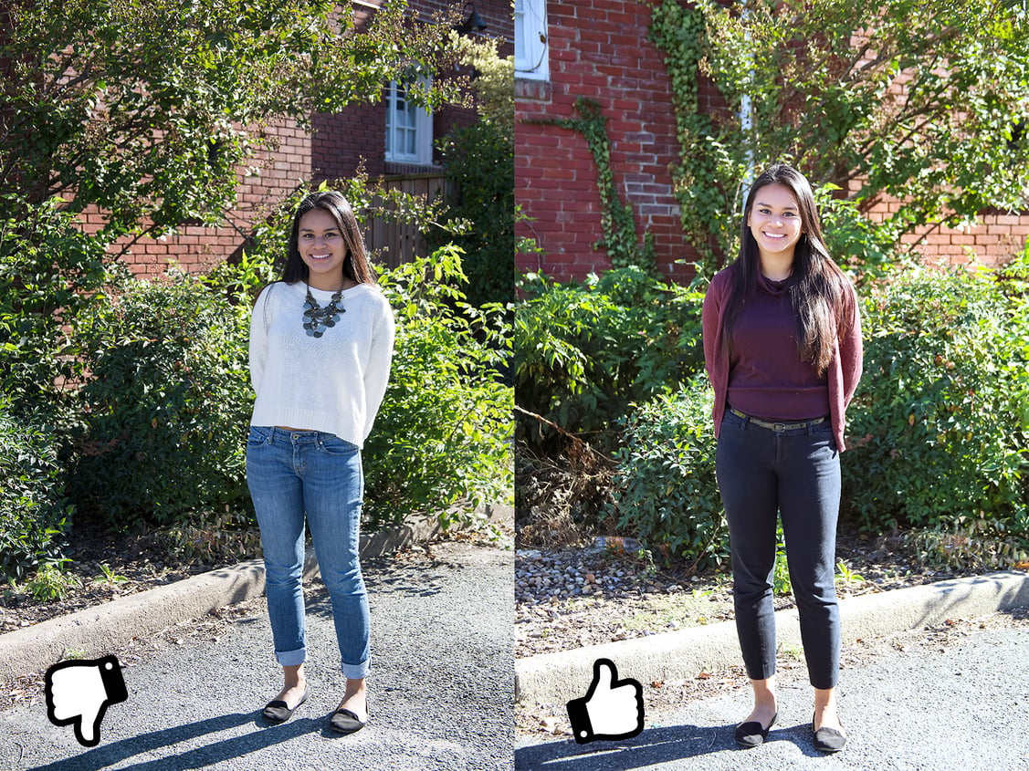

Situation #3: Indoors interview via Skype
There are instances when you and the interviewer are not sitting in the same room (as you’ve learned from our Skype interview blog post, we’re sure). Talking to your web cam doesn’t always make for the easiest delivery, so take one thing off your mental checklist by dressing the part.
The nice thing about this set up is being able to test out a couple of different options and see how they’re going to look on screen before you dial-in for your interview. Find the right room with the right lighting and check out how everything looks on screen.
Avoid wearing lots of accessories that can distract or add noise to your interview.
You should avoid busy patterns, particularly thin stripes, which can cause a moiré effect on screen. Stick with solid colors that don’t interfere with your back drop and allow yourself to dress comfortably, while still looking professional on camera. A Skype interview may be less formal than a tradition interview setting. Depending on the subject matter, men may not need a jacket.
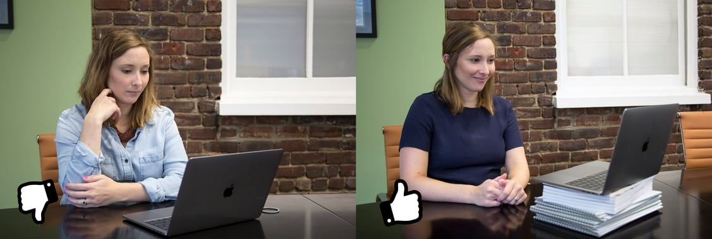
Situation #4: On-location interview with a busy background
If you’re at an event or somewhere with lots of people mulling around or you have a backdrop that has a lot going on, whether it’s indoors or outside, you need to make sure your voice is heard and you are clearly seen without distracting the viewer.
As with other outdoor or on-site interviews, make sure you wear something that easily allows a lapel microphone to be clipped on and hidden from view. If you’re on location with lots of movement behind you, keep your look clean and straightforward. Stick with solid colors and avoid prints or black and white, which may blend into the background.
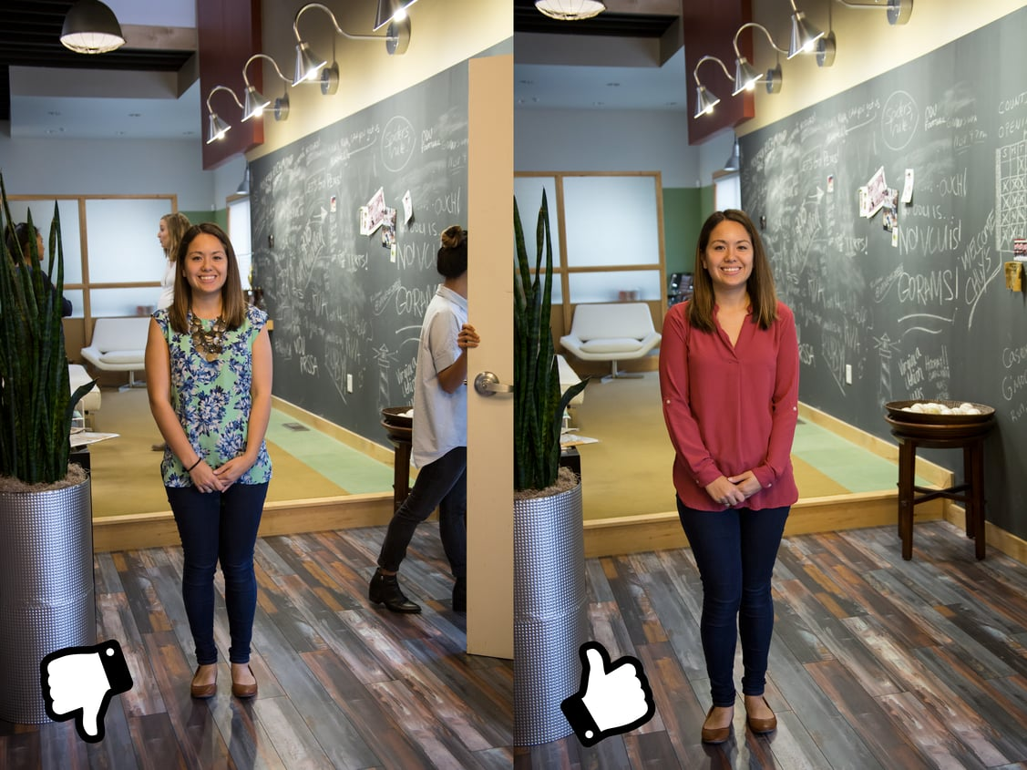

Situation #5: Interview in front of a green screen
There may be an opportunity where you’re on set, interviewing in front of a green screen (this may come up mostly if you’re doing a satellite media tour or another remote interview). Learn something from Sean Spicer’s St. Patrick’s Day tie incident earlier this year.
If there is one rule with green screens, it’s don’t wear green. You’ll also want to keep patterns to a minimum, as all of these can interfere with the chroma keying of the green screen. Stick with solid colors, an overall neat appearance, and depending on whether or not you’re sitting or standing, consider wearing a belt to help with the microphone placement.
Also consider your overall styling. If you have an elaborate hairstyle, you may wind up with bits of green screen coming through and not rendering correctly. Jewelry, scarves and other accessories could interfere, too.
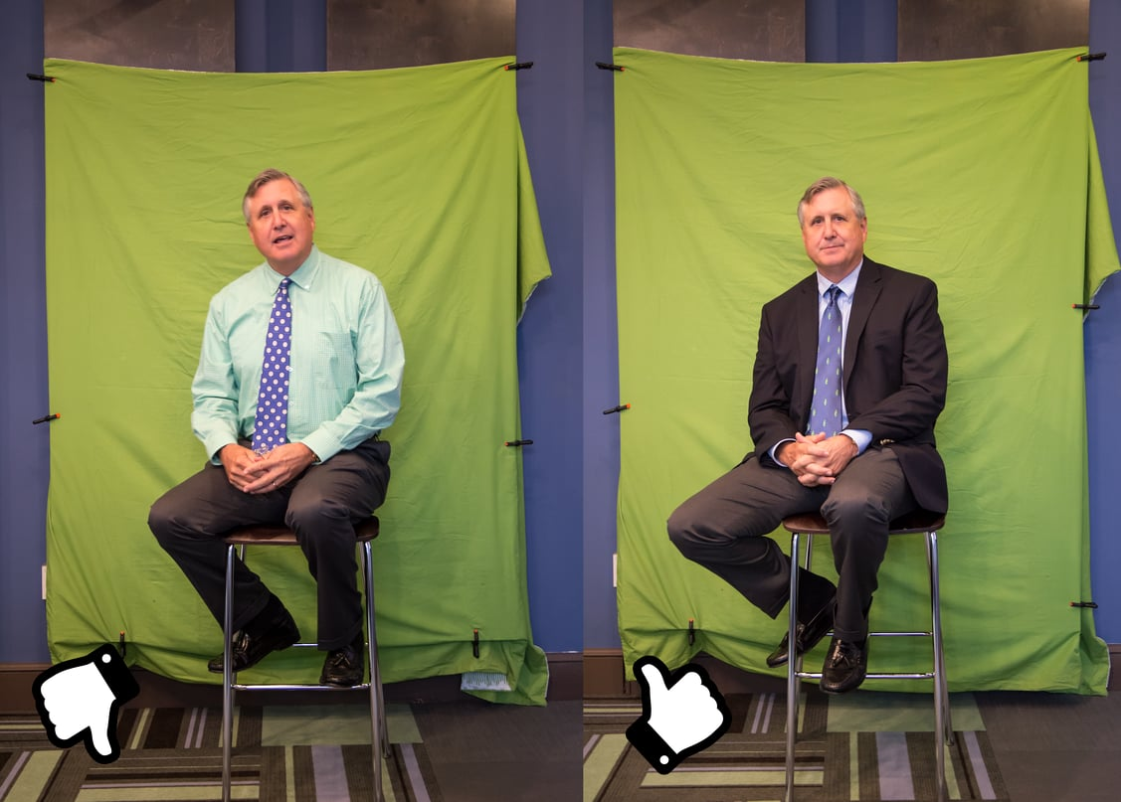 2016–2019 The Hodges Pa

